**Practical 1**: Create Web App in Azure and publish using File Explorer.

Step 1: Click on New blade > Web + Mobile > WebApp.

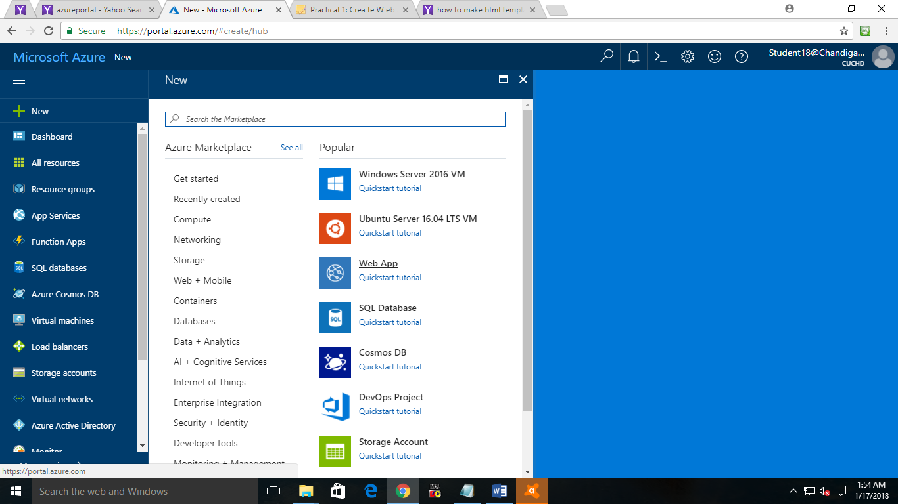

Step 2: Enter a unique name for your Web App and check Pin to Dashboard if you want to pin your application to dashboard and click on Create button and wait for the deployment.

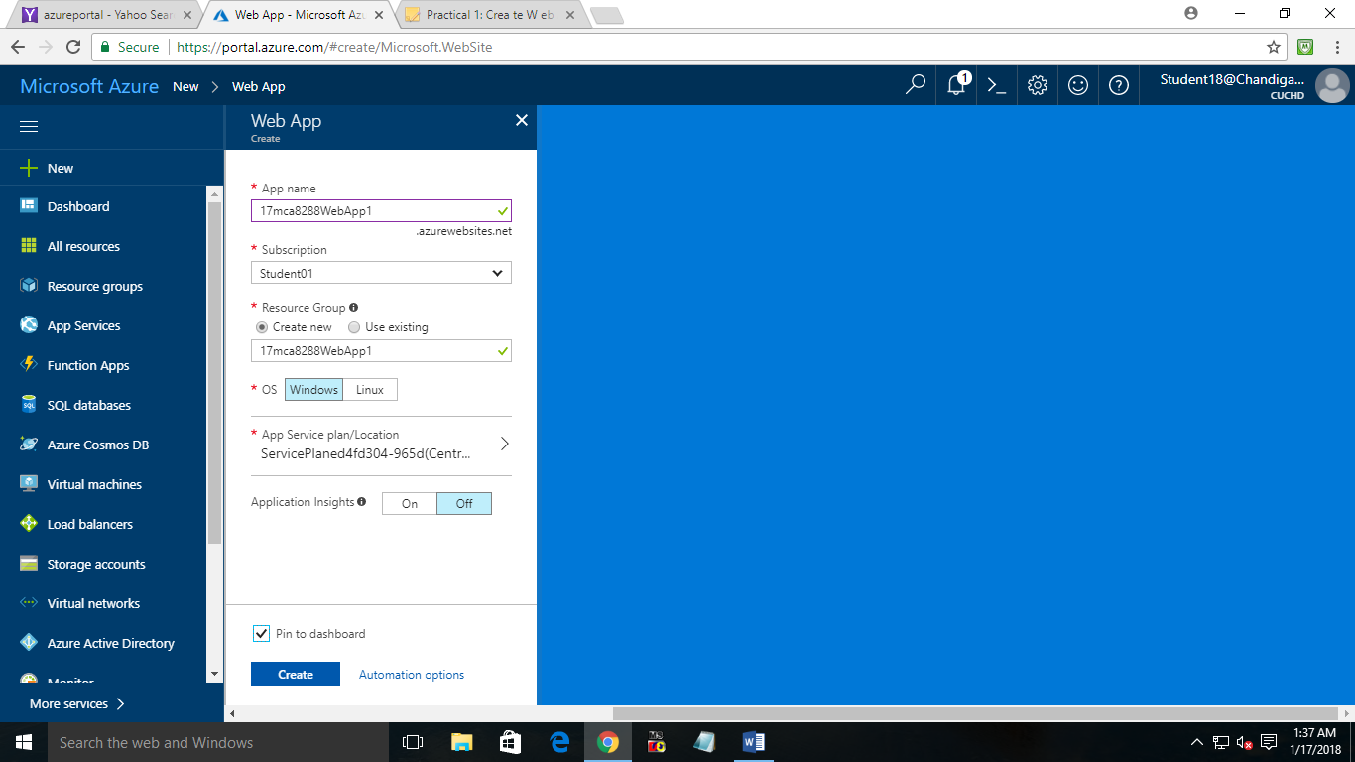

Step 3: Download the publish Profile by clicking.

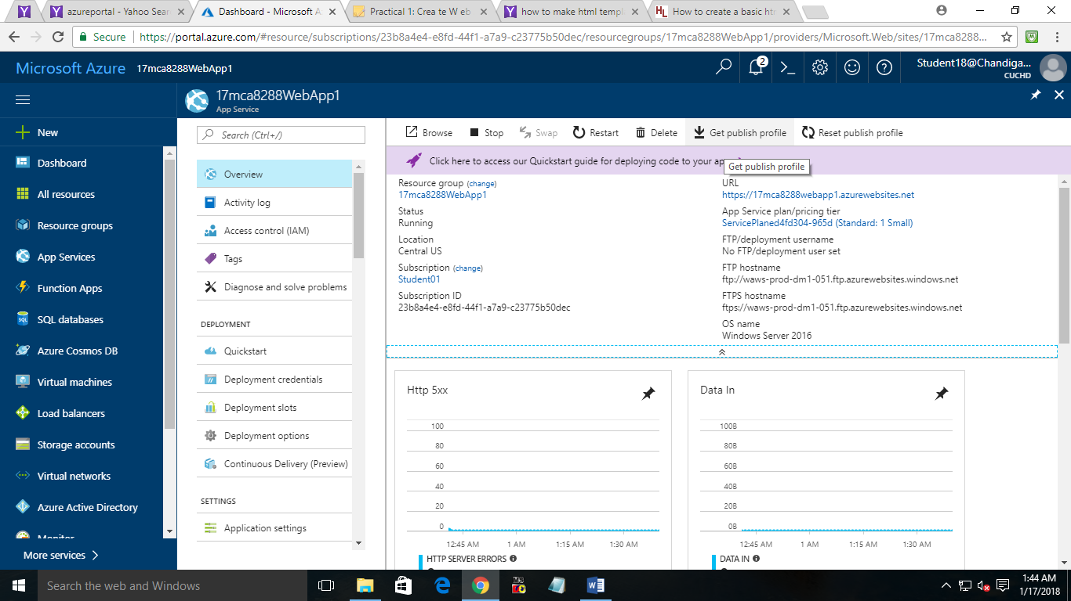

Step 4: Copy the publish URL and paste it in File Explorer and press enter. You will be asked for Username and Password, copy paste the FTP Username and Password from publish profile file and click Log on.

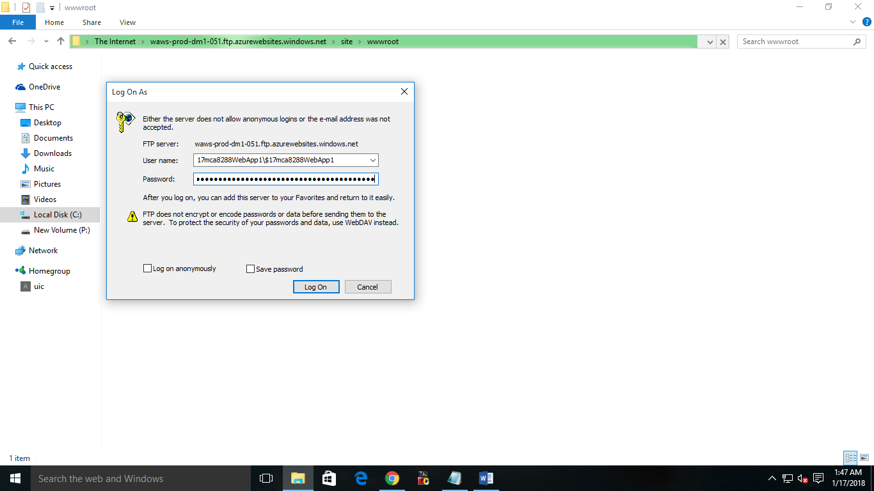

Step 5: You are now in the “wwwroot” directory. Paste your website here, wait until the files get copied.

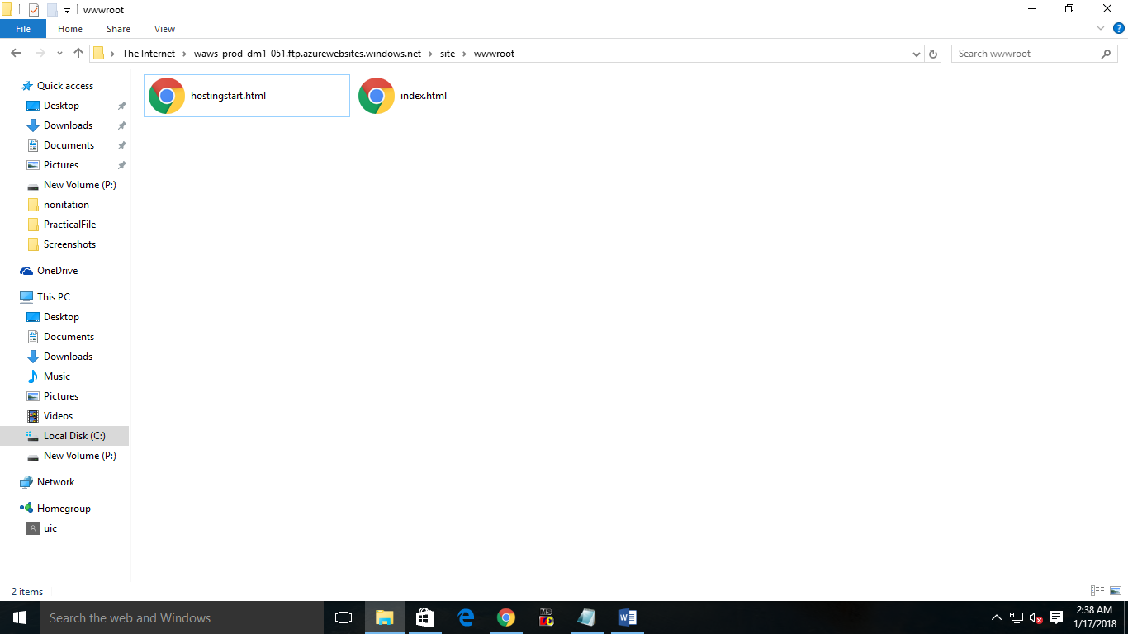

Step 6: Now from WebApp Overview click on the URL to open the website.

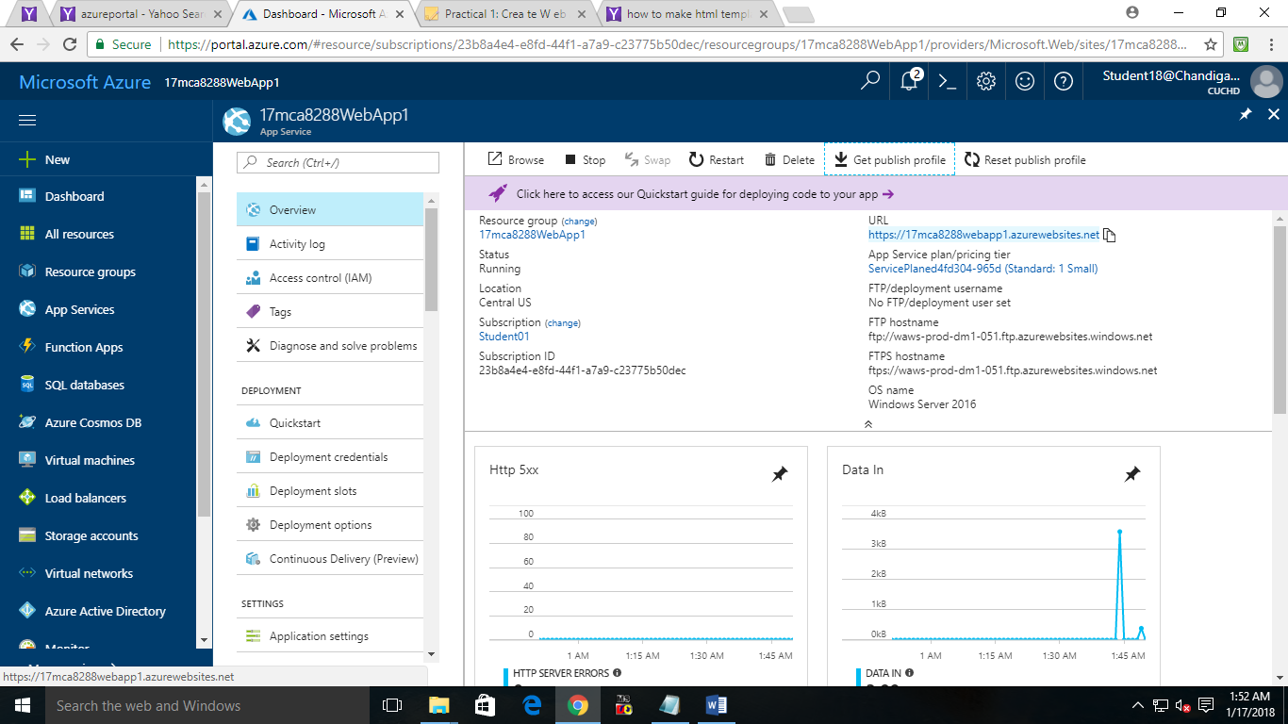

**Output:**

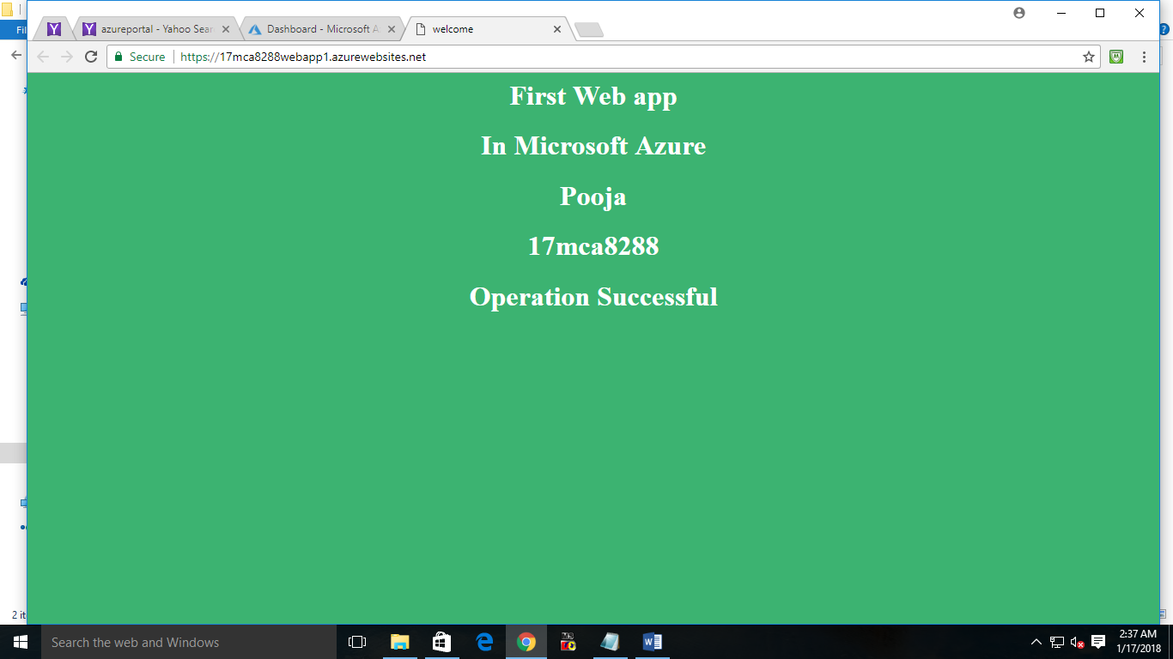

**Practical 2**: Create Web App in Azure and publish using Third party tool.

Step 1: Click on New blade > Web + Mobile > WebApp.



Step 2: Enter a unique name for your Web App and check Pin to Dashboard if you want to pin your application to dashboard and click on Create button and wait for the deployment

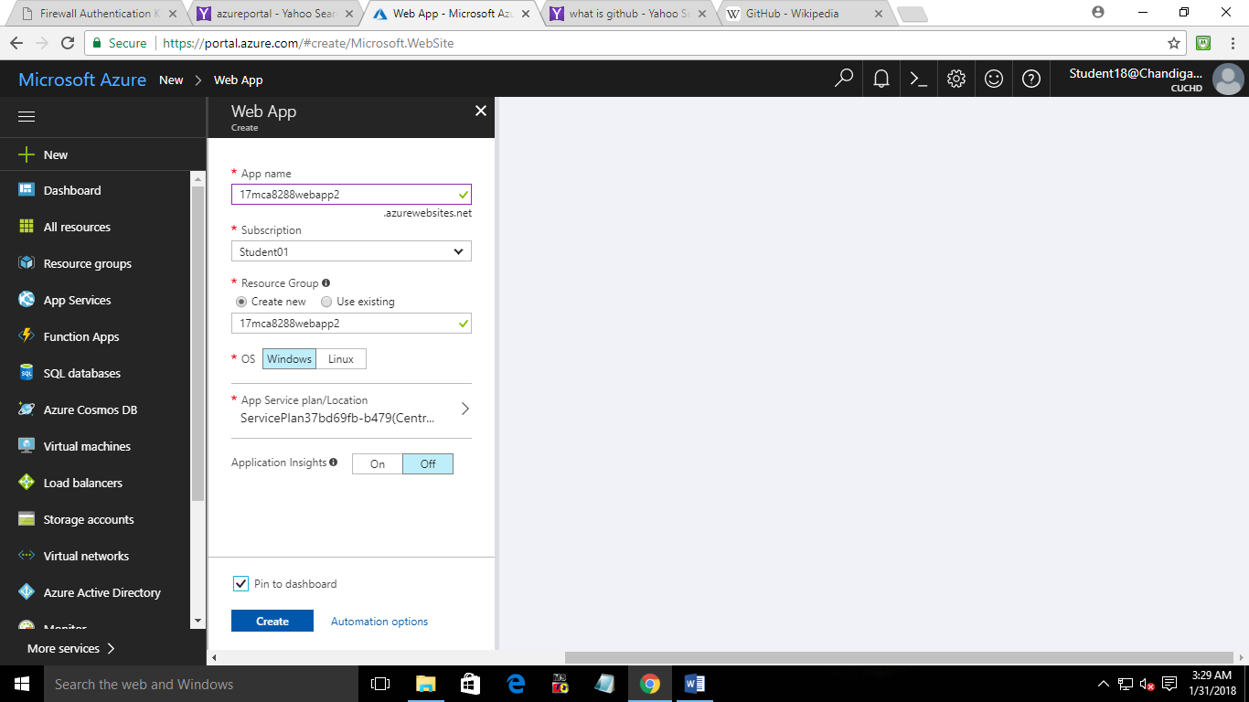

Step 3: Download the publish Profile by clicking.

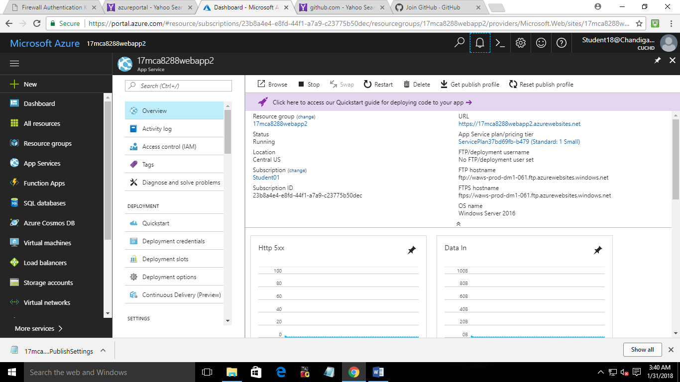

Step 4: Copy the publish URL and paste it in File Zila and press enter. You will be asked for Username and Password, copy paste the FTP Username and Password from publish profile file and click Log on.

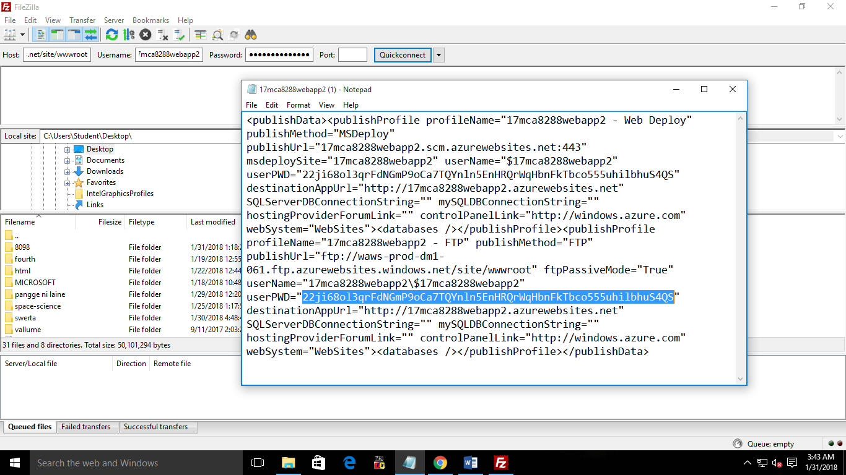

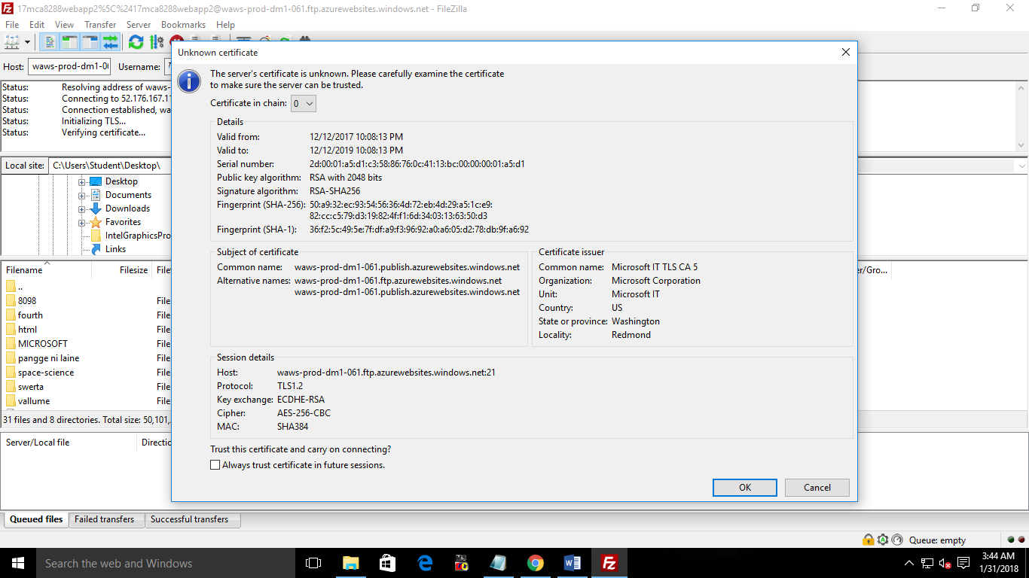

Step 5: You are now in the “wwwroot” directory. Paste your website here, wait until the files get copied.

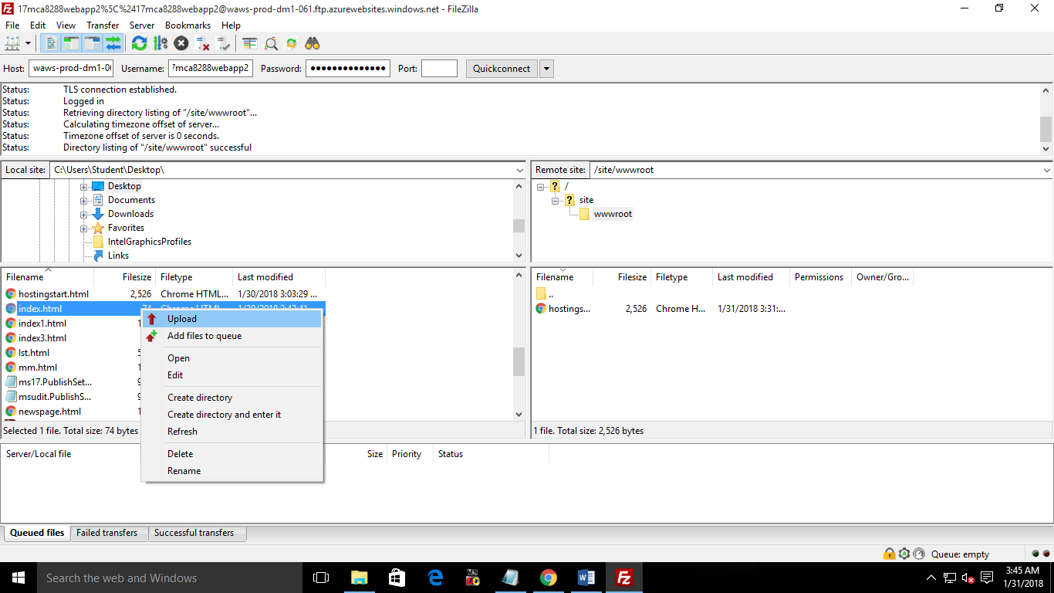

Step 6: Now from WebApp Overview click on the URL to open the website.

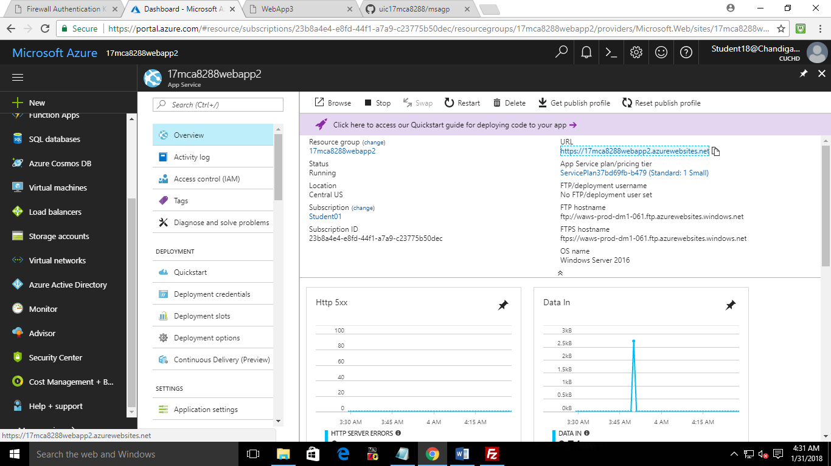



**Practical 3**: Create Web App in Azure and publish using Github.

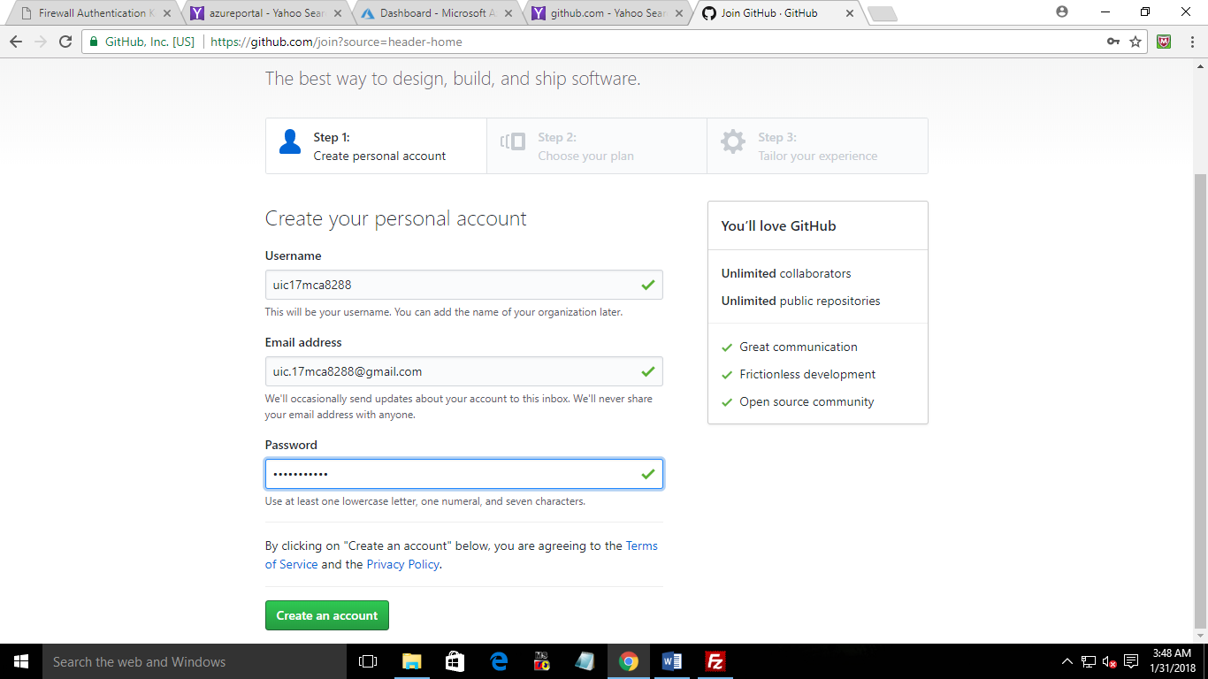

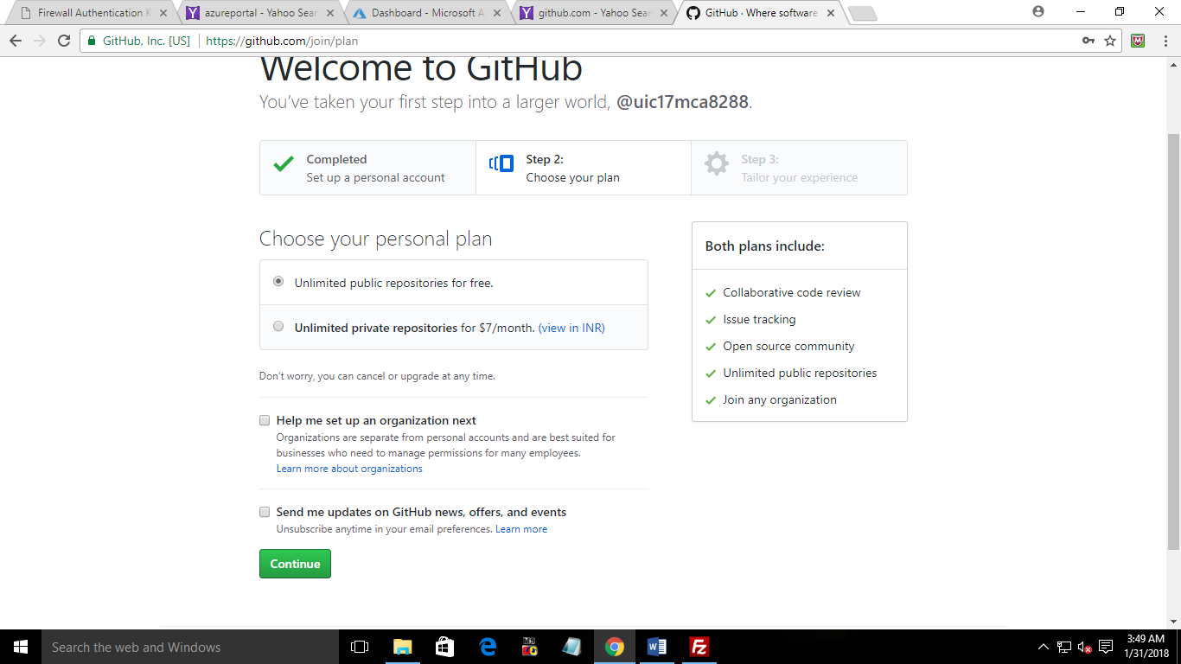

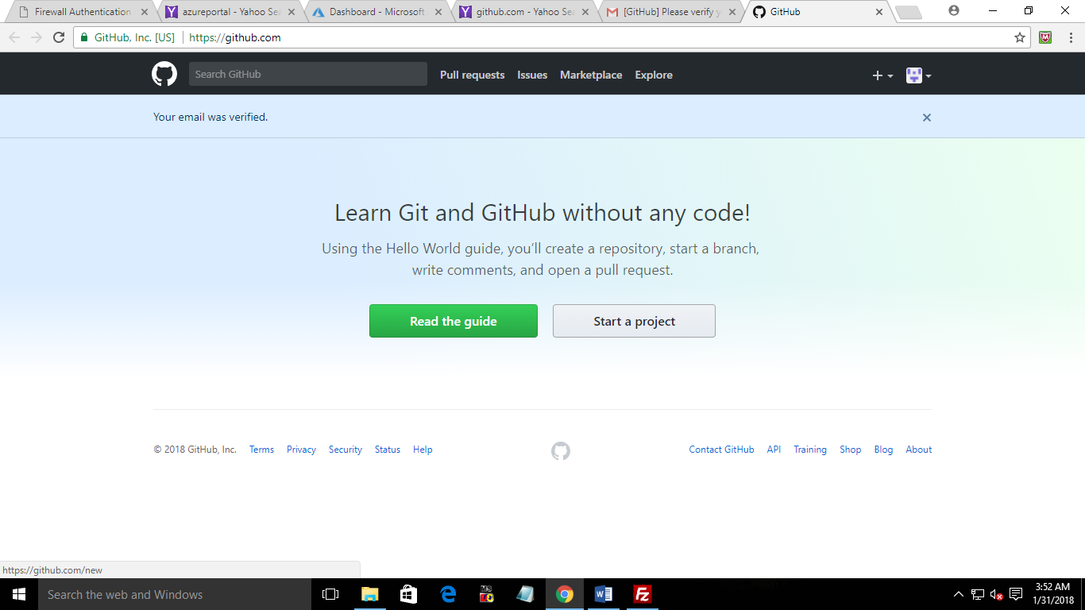

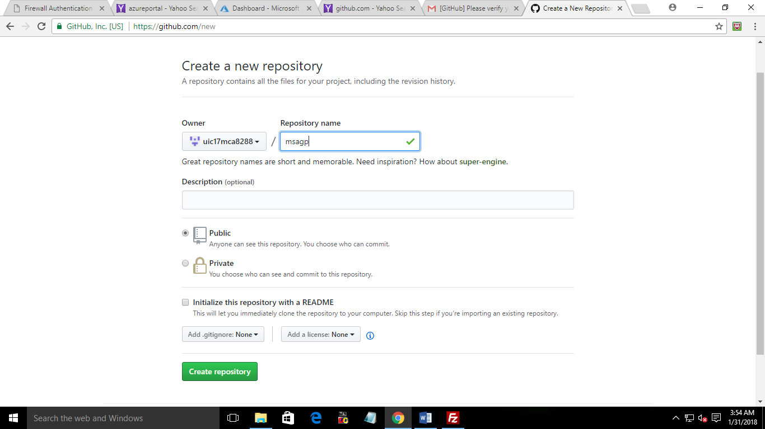

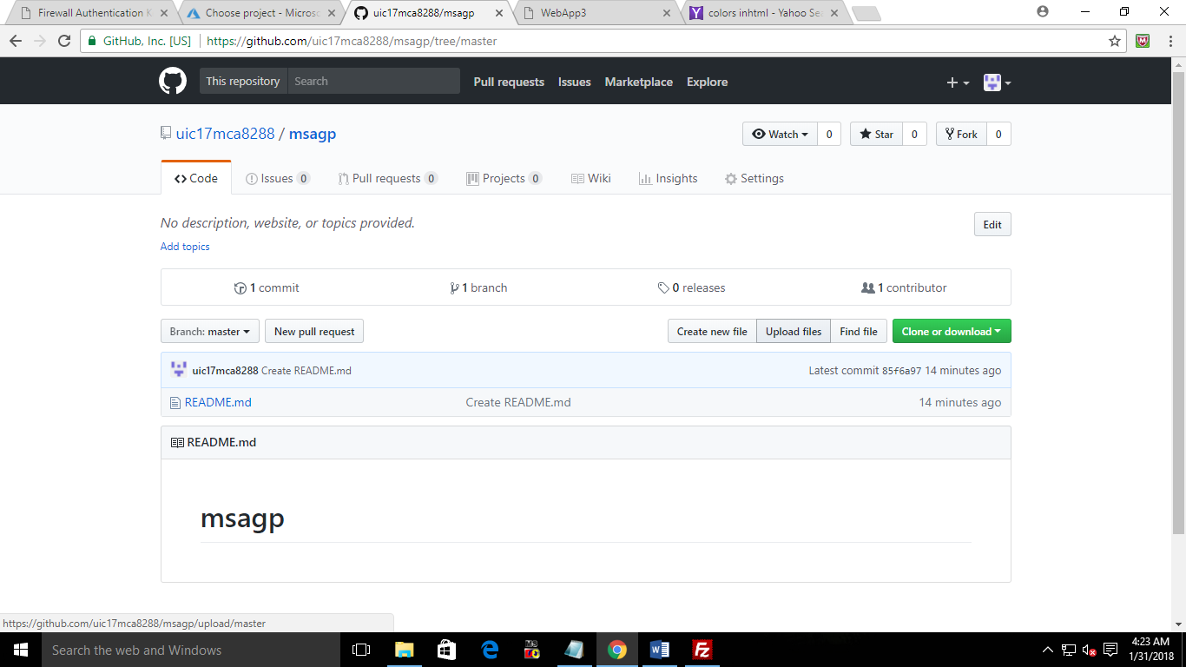

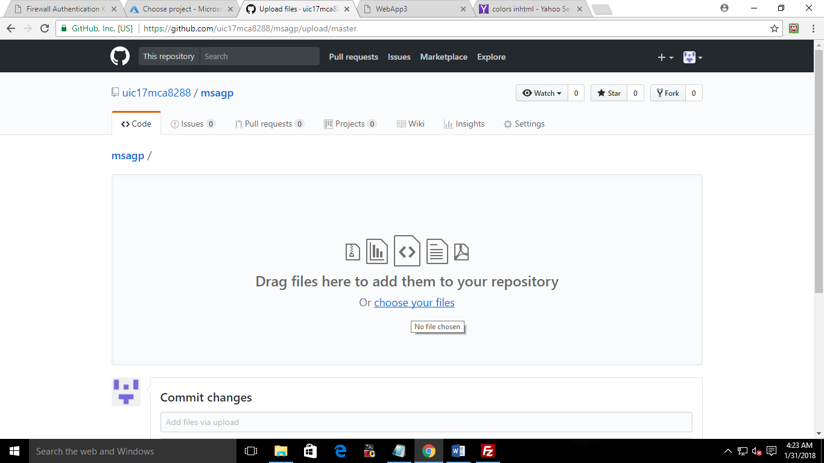

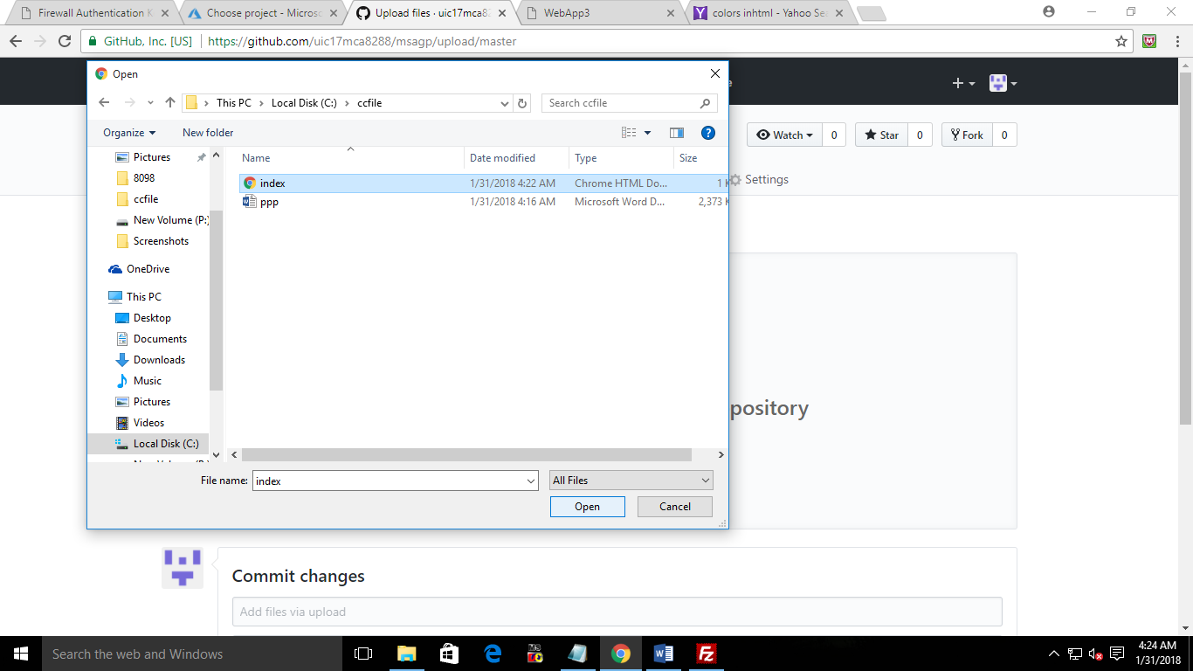

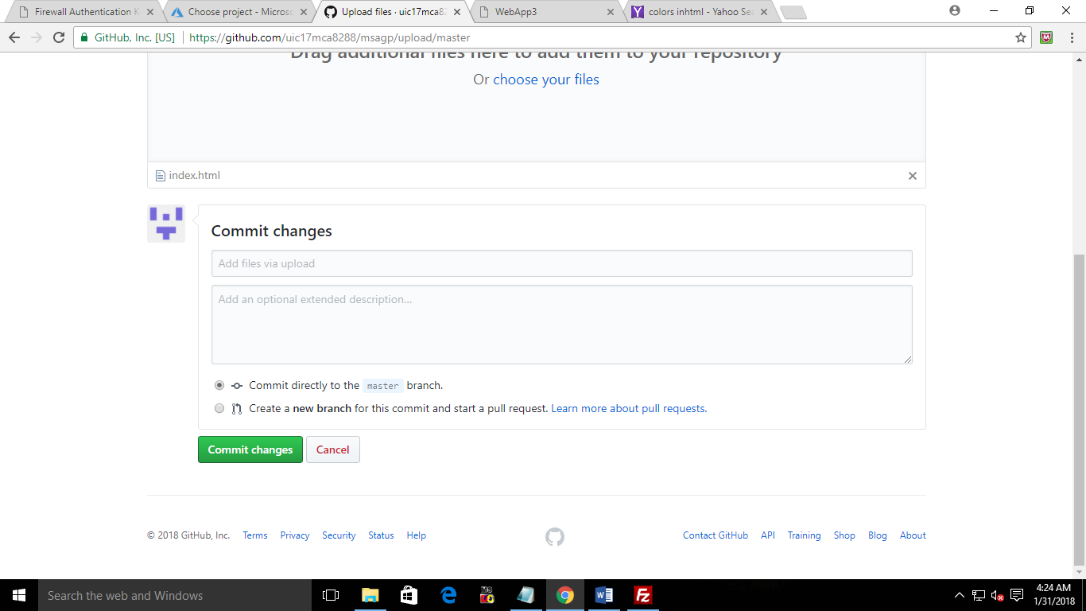

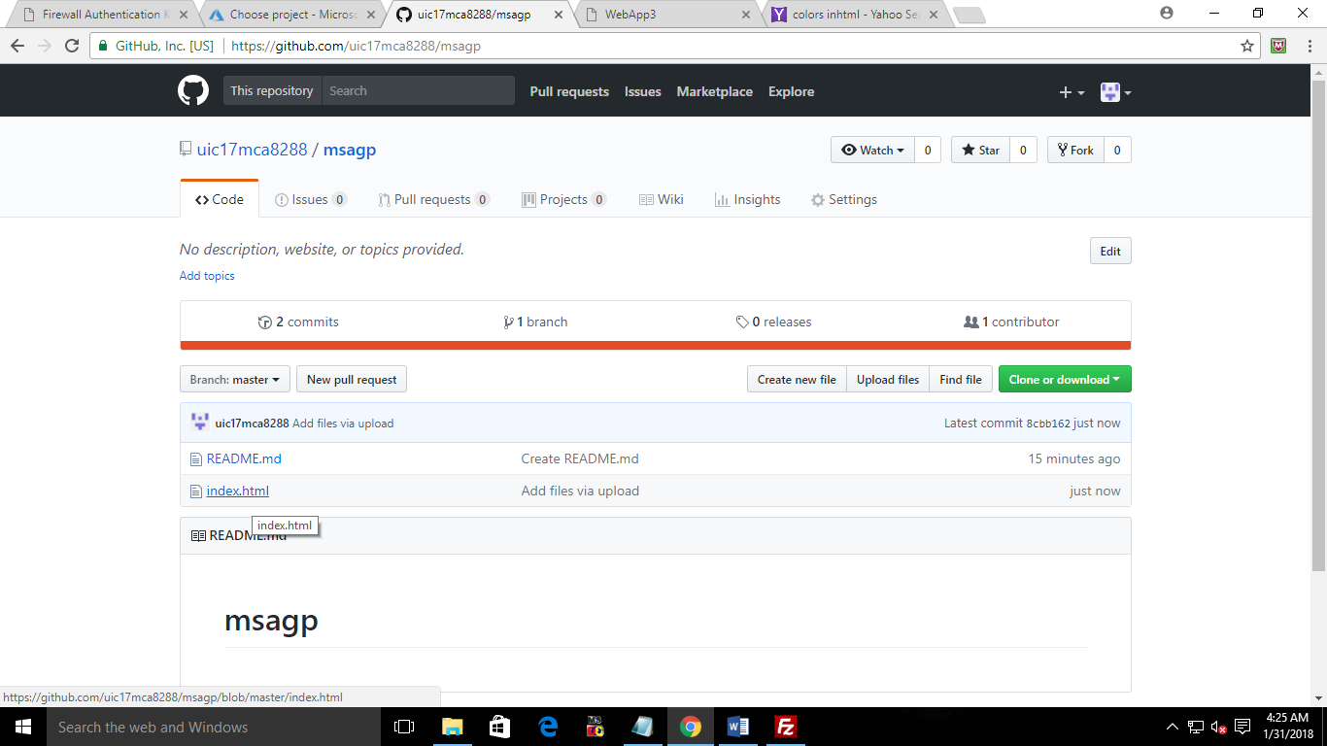

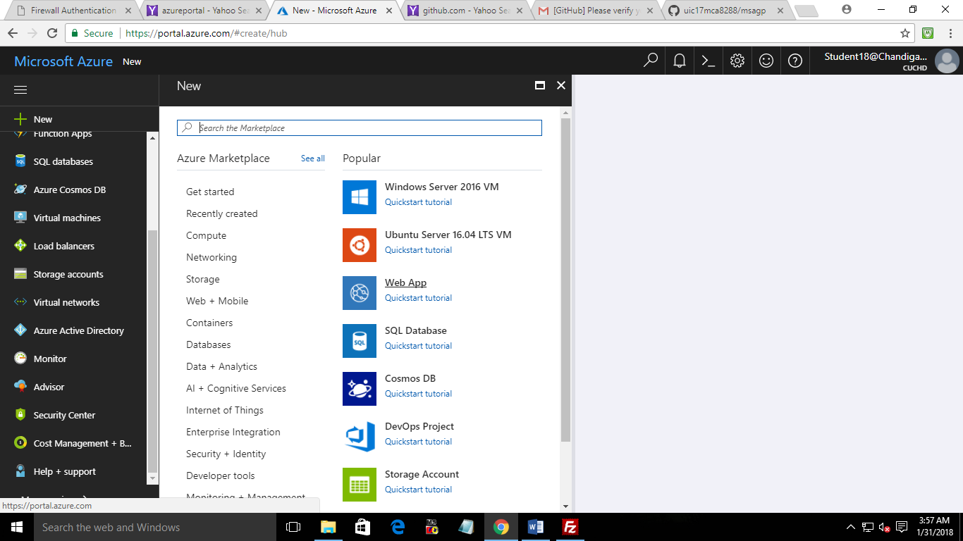

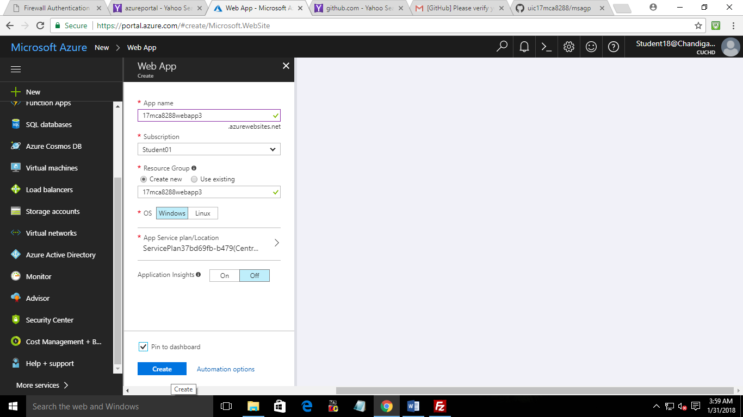

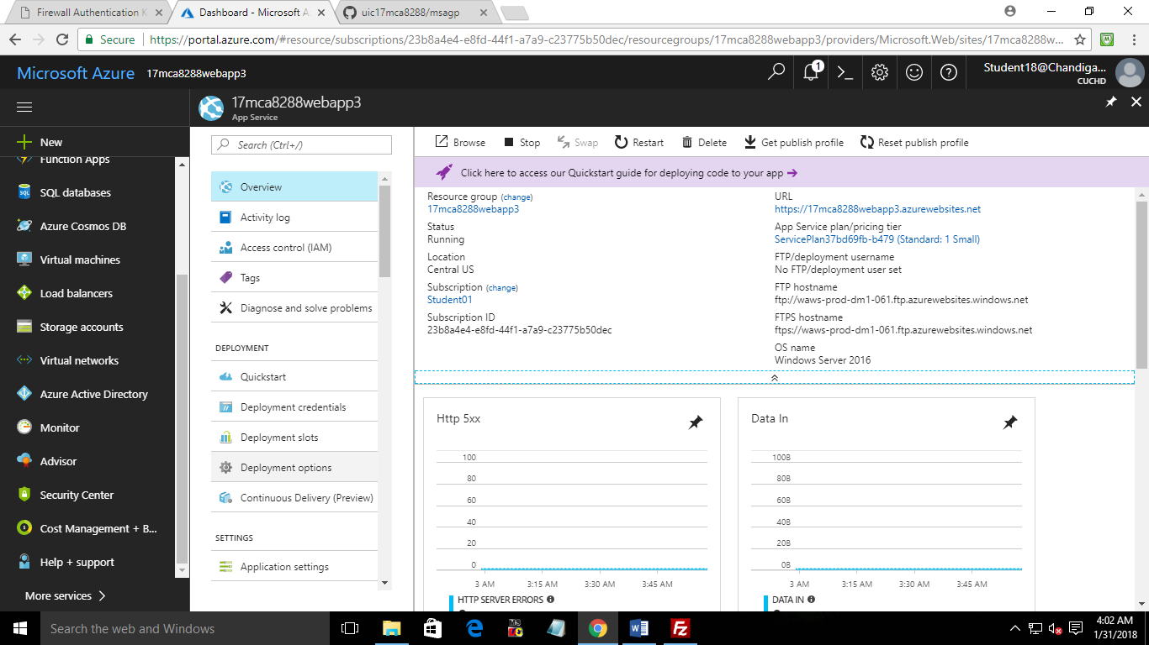

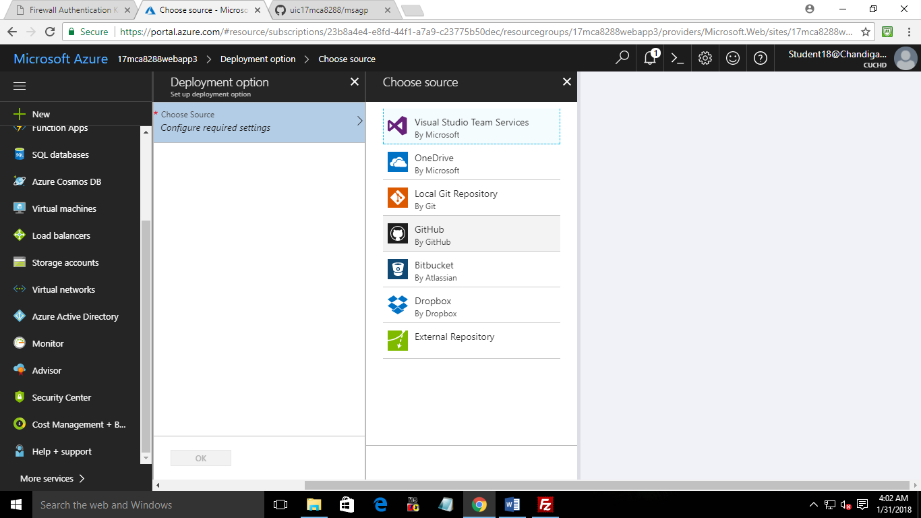

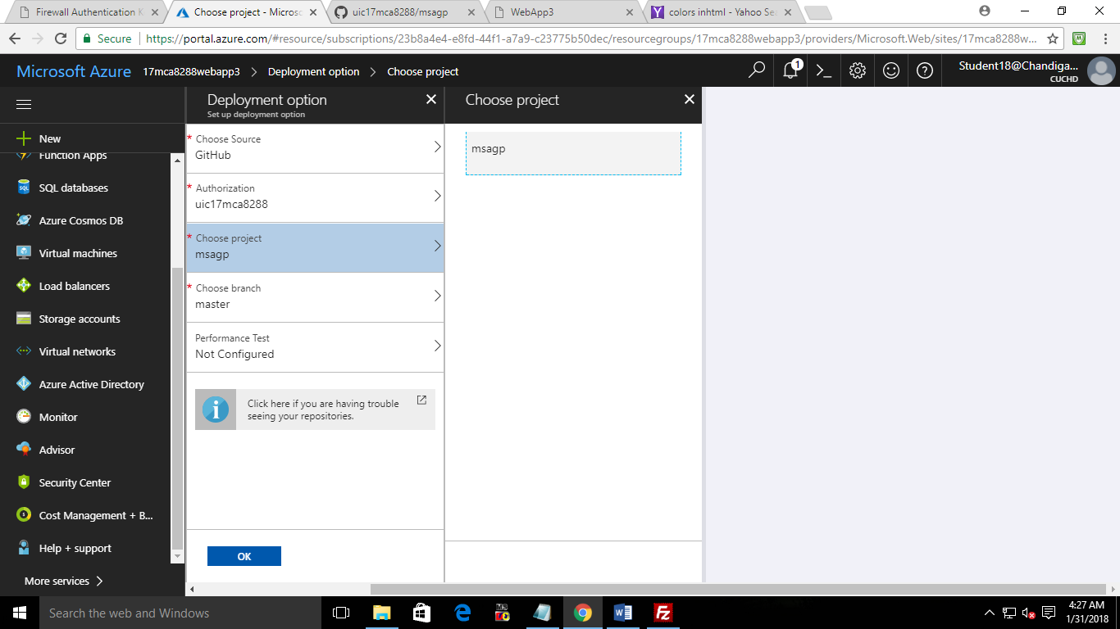

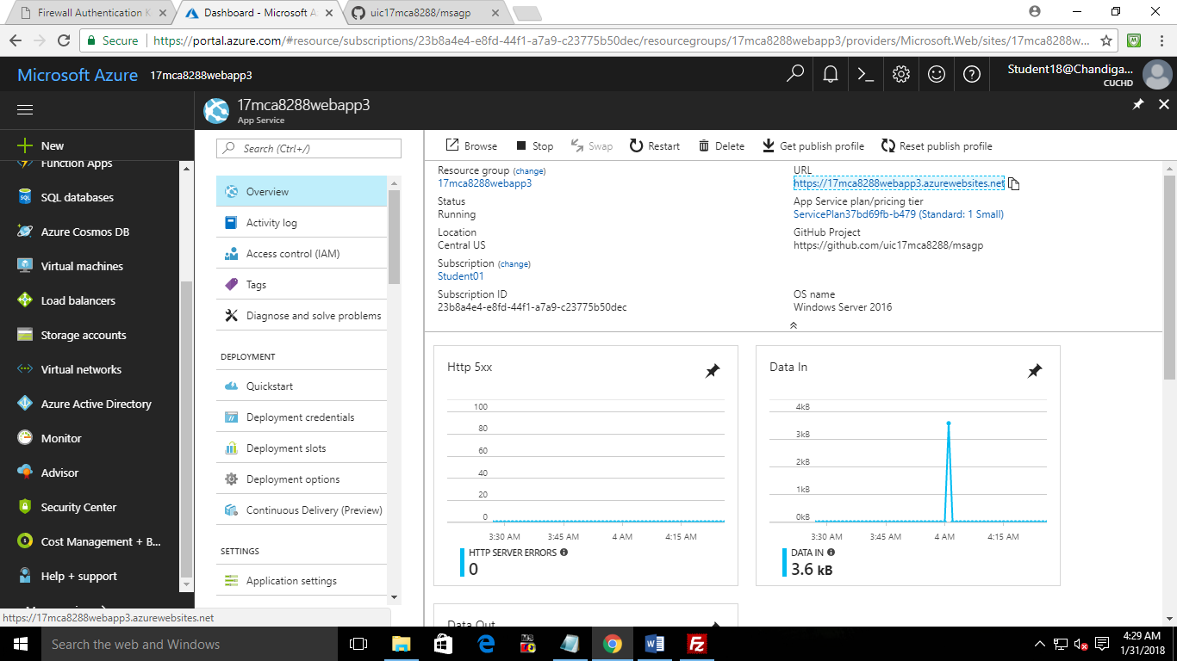



**Practical 4**: Create Web App in Azure and publish using Microsoft Visual studio.

